Chapter 13: In and Out of Business with Amazing People

It kept lingering in my mind that US athletes were not really supported to achieve their best in this country, unless they came from a lot of money and could afford master training. The US athletes had to be “amateurs” to compete, which meant they could not make money, but they still had to pay exorbitant fees to get the mentoring and coaching they needed. And, often their training was obtained at the cost of an education that might equip the athlete for other alternatives of earning his or her own way. A good many athletes “hung up their shoes” for this reason before they achieved Olympic caliber or even afterwards, cutting short their competitive lives before peaking. It didn’t make sense to me.
The Communist system, for all its terrible Machiavellian ways, did have the advantage of taking their athletes and sticking with them, training them, at no loss of education or cost to the athlete.
Dr. Dardik and I were continually pondering this. How could the US support our athletes financially and, at the same time, maintain their amateur status?
Finally I came up with one of my “crazy” ideas, which Dr. Dardick and I kept refining till we had a sound proposal. We even thought up a way we could raise funds for the USOC, while helping the athletes.
As far as we could see, it was a win win for everyone. The idea itself, as good ideas often are, was simple:
We would start a non-profit corporation by the name of Scientific Life Systems. This corporation would create training centers in every city in the USA. We would hire athletes to be trainers in these centers. The public would be more than happy to become members of these gyms and health centers where men, women and children could work out in one-on-one sessions with the Olympians. The Olympic athletes would get paid for this job which still qualified them as amateurs.
Meanwhile, the athletes could train at the centers while coaching the public. A percentage of the revenues would go back to the USOC to help offset the costs of training Olympians who could not afford all the dedicated benefits of attending an Olympic Training Center, such as Colorado Springs.
I decided to run it by William Simon, who was then President of the United States Olympic Committee.
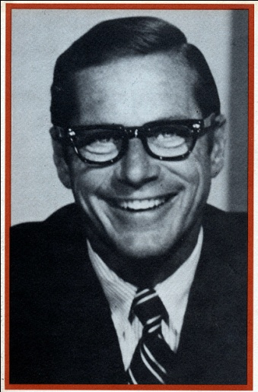
I respected Mr. Simon. In one of our meetings, he had given me his famous book:
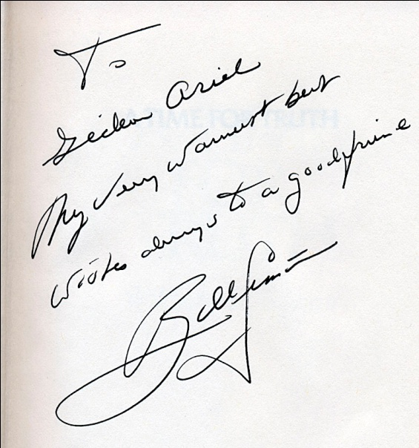
Simon’s “Time for Truth” referred to the political system. I thought it was about time we addressed a Time for Truth regarding our Athletic Training System.
This is the letter I received from Mr. Simon:
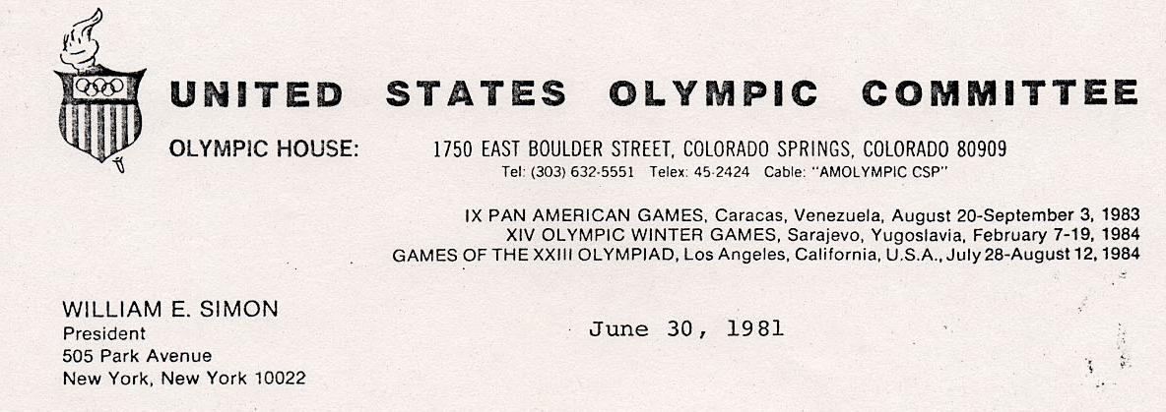
Dear Gideon:
Thank you for the recent letter updating me on the Sports Medicine program. I apologize for this belated response, but my schedule has kept me out of the office more than in recently.
I appreciate your forwarding this material to me and I am sympathetic to your concerns regarding the current state of the sports medicine program. As you and Irwin know, both Don Miller and I feel strongly that this program can provide a singularly outstanding benefit to our athletes in their preparation for '84 and we are committed to finding the best and most immediate ways to apply it to the existing programs of the USOC.
I will be in touch with you once I have had the chance to take a closer look at the package you have sent to me and can respond in more detail.
With warm regards,
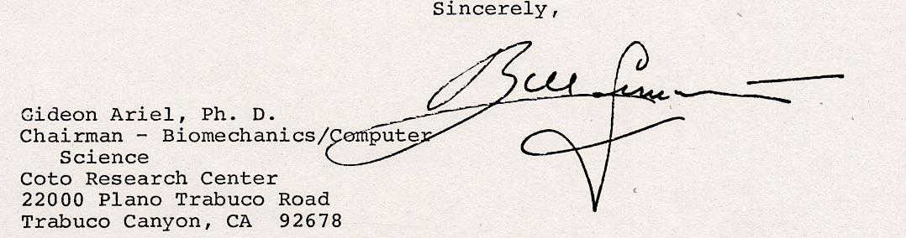

It turned out, William Simon liked the idea. One of his best friends was William Casey, the CIA Director at the time. Simon contacted Casey and the four of us, Simon, Casey, Dardik and I had a meeting where we decided to embrace our proposal and form the Scientific Life System Corporation.
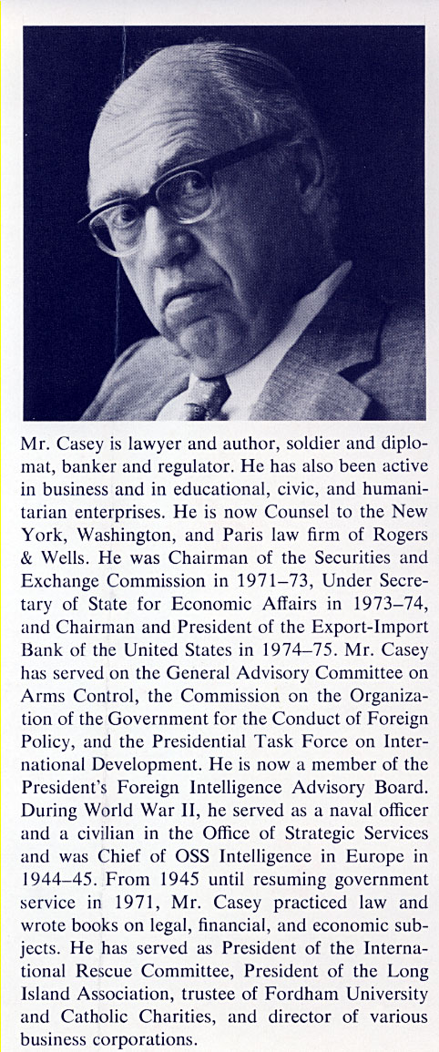
William Casey also gave me his book:
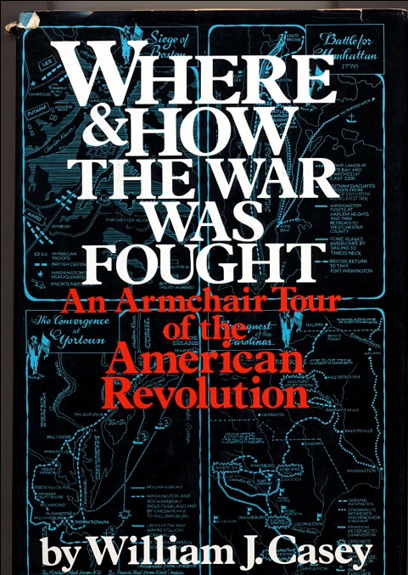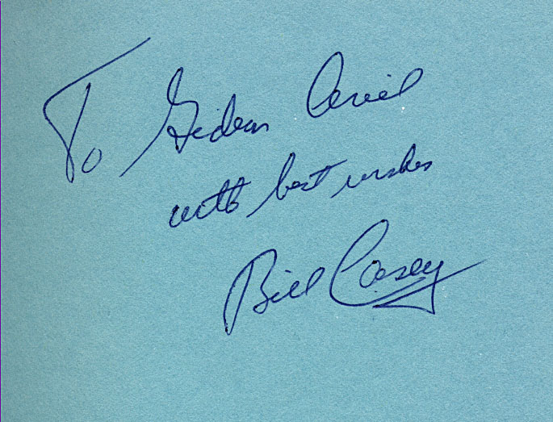
Mr. Casey’s war was on the battlefield and in the spy world, beating enemies with bullets and covert intelligence. My war was on the athletic field spying on our competitors and learning how to beat them with our talent and technology. In Casey’s war, one could lose a lot of lives. With my system, the worse that could happen was you could lose an Olympic Medal.
We were on our way, busy ironing out many of the details. I include the following letter for a reason. The items listed were our considerations.
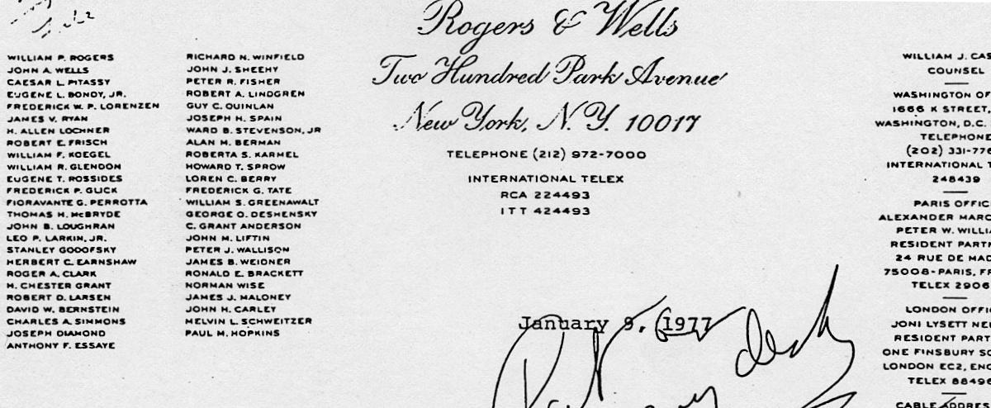
Dr. Gideon Ariel, Dr. Irving Dardik
Hon. William E. Simon
As agreed at our meeting on December 23rd, I have formed a Delaware corporation named Scientific Life Systems, Inc. with 1,000 shares authorized. Here are some things we might try to crystallize further when we visit Amherst on Saturday:
1. In order to complete the organization of the corporation we will have to determine how the $100,000 which Simon and Casey would invest and the two businesses to be transferred to the corporation should be reflected in the 25% equity interest which we talked about on the 23rd. Should any notes be issued in the capitalization, should the corporation elect under subchapter S with a view toward making it possible for the investors to deduct R and D expenditures on their individual tax returns, etc. In order to make those decision we should have recent financial statements of each of the businesses being transferred into the corporation and a projection of its operations for the current year.
- In order to present a tangible proposal to Palmieri as soon as possible we should
work out a pro forma balance sheet and a set of projections for a physical fitness center on the scale which we think would be appropriate at Palmieri's development. We also have to formulate what kind of a combination of ownership interest, management compensation, franchise fee and equipment price or rental we should get for developing, supporting and managing that kind of a center.
- Since a good part of the new money will be going into developing equipment, we should have a patent opinion. I have talked to Greason about this. He tells me he has not yet obtained the information he asked Gideon for some time ago. I think it would be a good idea to bring him along on Saturday so that he can get a first-hand impression of the equipment concepts.
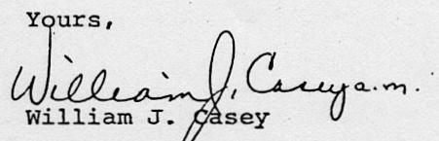

So we began. We opened a pilot fitness center, in Englewood, New Jersey. The Center was equipped with the latest variable resistance exercise equipment and staffed by dedicated and intelligent United States Olympic athletes, offering individualized fitness training programs to suit the needs of its members. Young, old, fit or unfit could work with their athletic heroes in 30 minute training sessions.
The Center also was dedicated to serving people with specialized medical problems who could not find suitable fitness regimens elsewhere. One of Dr. Dardick’s main concerns were diabetic children. He was well aware that diabetes patients are prone to cardiovascular complications that are the most common cause of their early death. One of the most effective ways of forestalling this is by a lifetime habit of exercise designed to maintain the circulatory system in peak tone. Historically, this has been the most neglected aspect of diabetic treatment, principally because of the unavailability of suitable training programs (compounded by difficulty of motivating the young diabetic patient, who discourages easily, feels himself different, and is too readily allowed to slip into the attitudes of illness). When working with juvenile diabetics, we found that they responded with enthusiasm and renewed self-confidence to the presence and influence of Olympic athletes.
In fact, Dr. Dardick was concerned about the wellbeing of all people and saw these centers as improving the general health of peoples throughout the country, using preventative medicine programs.
We also saw the benefits of courting businesses so as to improve the health as well as the level of on-the-job performance of executives and their employees. Our centers would help correct specific physical problems that arise from white collar jobs, such as lower back problems that office workers all suffer from.
Physically handicapped and paraplegic patients were another group whose survival and quality of life are especially dependent on a commitment to physical conditioning. We therefore developed special programs for such patients concentrating on body strength and cardiovascular conditioning.
That was the rationale for the Centers’ helping Americans young, old, sick and strong. But the advantages for the Olympic athletes were just as important. These nationwide training centers were an opportunity to maintain their amateur status, while engaging in a rewarding and useful career and enjoying the friendship of a congenial community of athletes. It was an opportunity to continue training without financial sacrifice, as well as an opportunity for systematic training under the guidance of colleagues who are qualified doctors and coaches and in a program whose advanced techniques.
Added to that there were many benefits that would flow to the USOC from the superior performance of the Olympic athletes, their happiness and economic security which would render them loyal to the Olympic Committee. In addition, it would increase the USOC’s ability to discover new athletic talent, with outreach programs where Olympic athletes would provide training guidance in community schools and youth centers. And, direct revenues would flow to the USOC from the program itself.
We now had two centers in operation. One in New Jersey and one in Washington D.C. We had more requests for membership than we could fill. Olympic athletes from different events were hired. They were practicing for their event and at the same time coaching young children and running fitness programs for the adults. It was a fantastic success, functionally and economically.
We had plans to keep enhancing SLS. We wanted to make a more defined nationally oriented corporate executive program, as well as our general public and community program.
We also wanted to add to our program routine physical examinations, such as cardiac stress training, exercise and nutrition programs that were computerized as well as a biomechanical analysis of tennis and golf swings and other sports.
A third division would be related to my work. And this would include the development and manufacture of computerized exercise equipment that could be used not only in training centers but in hospitals and rehabilitation clinics for specialized work such as injury rehabilitation, cardiac rehabilitation and the like.
We were in the process of implementing this extraordinary program. We had the backing of such notorieties as Simon and Casey, and the support of Colonel Miller, the director of the Olympic Committee.
While we were starting to implement the program, Mr. Casey, at one of our meetings in Amherst, saw me analyze the Dow Chemical legal case related to the head injury of a gymnast and the effect of the mats which allegedly caused the injury. Casey immediately noticed the potential for our technology in the area of Workmen’s Compensation. We had already done a little in this area but Casey wanted to take it big time.
He developed a marketing plan to accomplish this. He saw a future where all product advertising for sports equipment would have CBA approved on it. In addition, CBA was in the unique position to test the nature of serious injuries, and whether they were caused by surfaces and the like, such as in an April 6, 1978 New York Times' article which indicated that artificially surfaced football fields may be the cause of pronounced increases in foot, ankle and knee injuries. CBA could have settled that argument.
In the products liability area, CBA had already undertaken two types of cases: materials cases and non-materials cases. The Johnnie Carson case fell under the latter category while the Dow case is actually "materials testing."
Casey and Simon were on to something. Their vision was on the mark. Product liability was having a devastating effect on many industries because of the increasing number of court suits, excessive court awards, and spiraling insurance premiums. Product liability cases even today number over 4 million. The average settlement of a product liability case is $300,000.
According to the US Commerce department, the industries hardest hit by product liability are those involved in manufacture of machinery, sporting health equipment, toys, medical equipment, and drugs. Of every liability dollar spent by these industries, 56% of it goes to legal fees and costs. This expenditure, known as the Gross Legal Product (GLP), rose from $2 billion in 1955 to $15 4 billion in 1976. Now it must be in the $300 billion range.
Companies were already using us to analyze their product liability. The Dow Chemical Company, as a result of the previous case, had contracted us to determine impact analysis on all their foam products. In addition, the Riddell Corporation, the leading manufacturer of football helmets in the country, contracted CBA for a study analyzing the design liability of football helmets.
The workmen's compensation business was another virtually open marketplace that Casey and Simon were interested in. It was practically impossible to estimate gross revenues in this area.
Even now, workmen's compensation claims reach over $30 billion each year. To date, there has been no precise system to measure degrees of disability, and as a result, insurance companies have resorted to general formulas to determine the amount of workmen's compensation.
Using biomechanical analysis, the actual degree of a worker's disability can be measured, within a very small margin of error. This margin of error can be eliminated if the worker is tested biomechanically before an accident has occurred. The worker's ordinary flexibility can be recorded and used as a standard once an accident has occurred. The comparison of a worker's pre-accident flexibility and post-accident flexibility will determine exactly the extent of the injury. Thus, through biomechanical application, a system can be provided that will consistently determine the extent of injury and workmen's compensation amounts. The result would be a substantial savings for any company that pays sizeable compensation fees. This analysis system would have similar attraction for insurance carriers who are constantly involved with accident claims.
The entire products liability and workmen's compensation business, in Simon and Casey’s eyes, could evolve ultimately into long term multi-million dollar agreements with insurance carriers. This was highly desirable to me, too, since CBA required "stream" income to give us stability. Project by project income was less reliable because of the limited life of the contract.
Simon and Casey saw the overall market in excess of $100 billion, but this was admittedly speculation. But they did see a plethora of companies who would be interested in Product Liability testing. These would include everyone from Aetna Casualty and Surety Company to Liberty Mutual Insurance Company to Fireman's Fund Insurance Company to Travelers Insurance Company and more.
So things were looking very positively. There were incredible business opportunities on the table that would benefit both CBA and the insurance companies. Our training centers were doing astoundingly well. We were employing Olympic athletes, coaching young children as well as helping the general population to get fit while helping our athletes achieve their goals.
And, then a bomb shell exploded.
In November, 20th 1981, about one hundred newspapers came out with the following article:
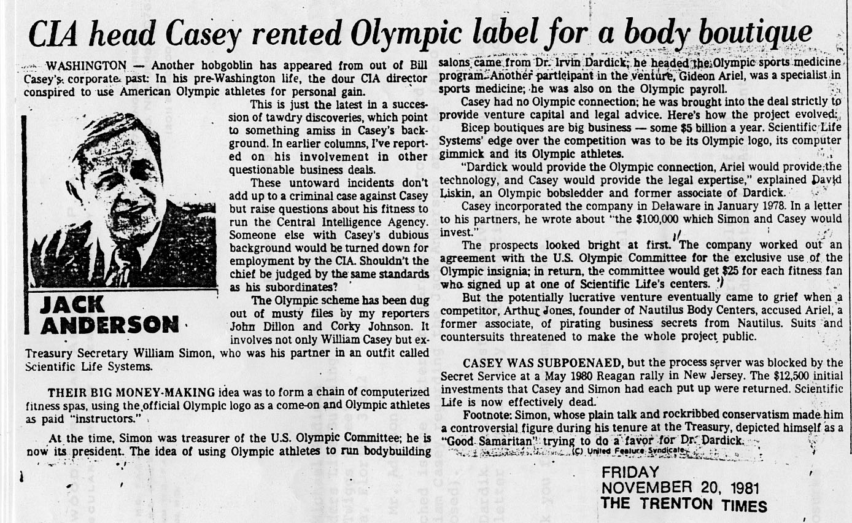
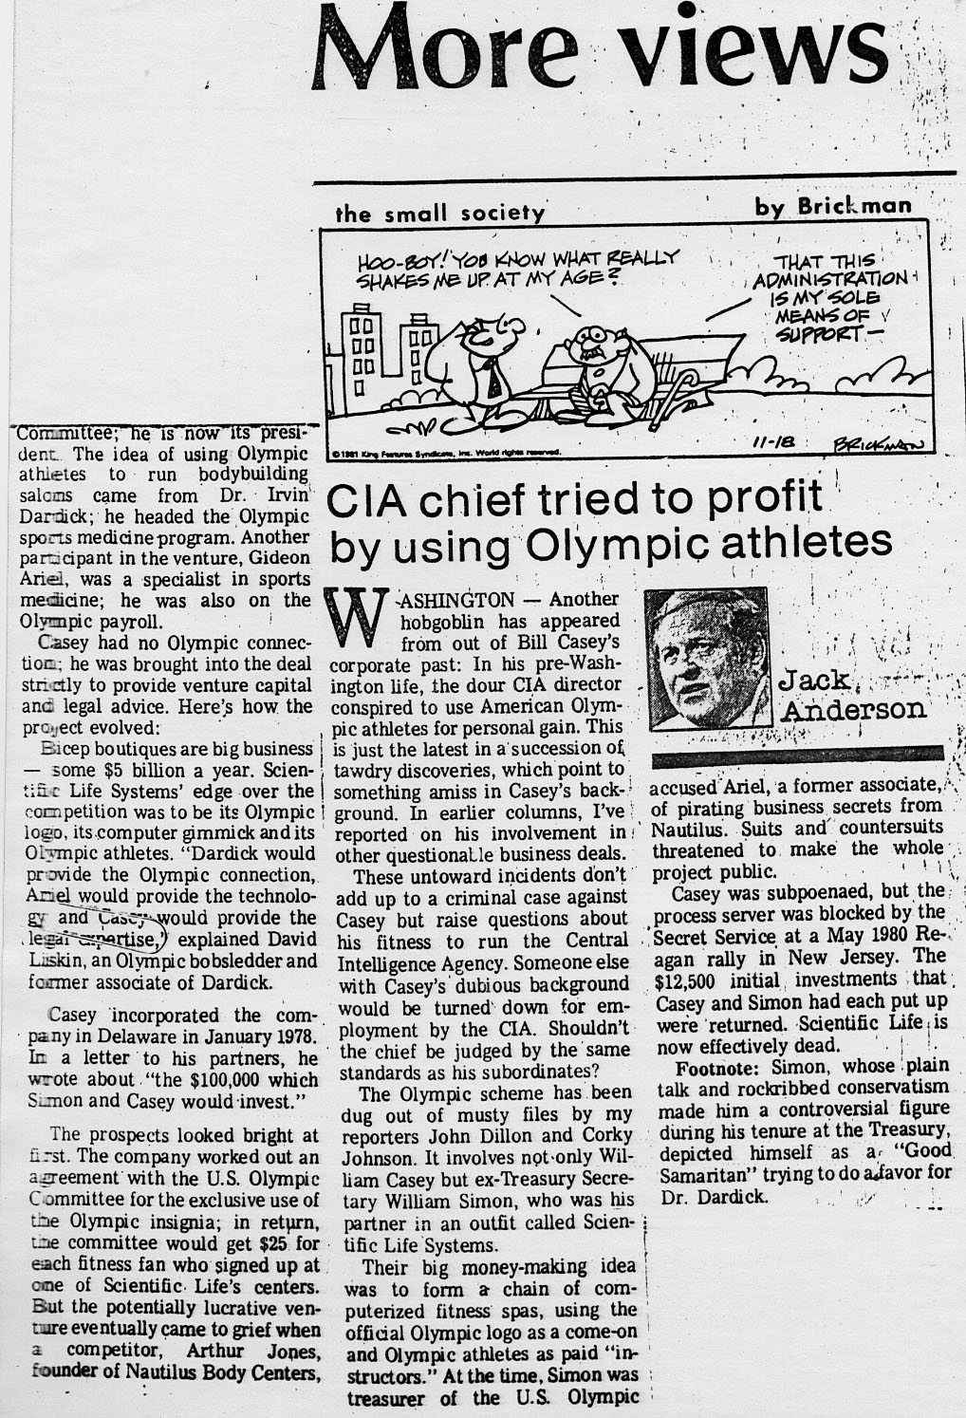
The scanned text reads:
WASHINGTON — Another hobgoblin has appeared from out of Bill Casey's corporate past: In his pre-Washington life, the dour CIA director conspired to use American Olympic athletes for personal gain.
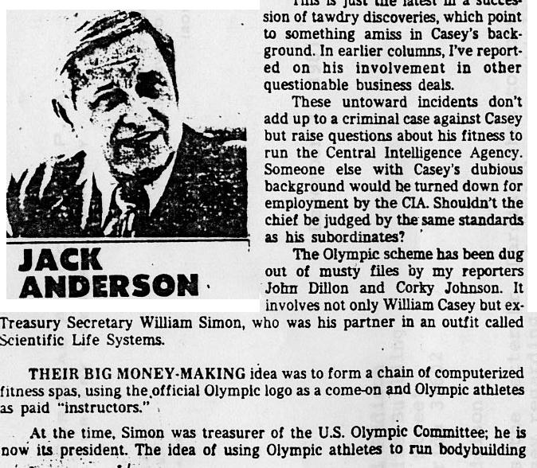

This is just the latest in a succession of tawdry discoveries, which point to something amiss in Casey's background. In earlier columns, I've reported on his involvement in other questionable business deals.
These untoward incidents don't add up to a criminal case against Casey but raise questions about his fitness to run the Central Intelligence Agency. Someone else with Casey's dubious background would be turned down for employment by the CIA. Shouldn't the chief be judged by the same standards as his subordinates?
The Olympic scheme has been dug out of musty files by my reporters John Dillon and Corky Johnson. It involves not only William Casey but ex-Treasury Secretary William Simon, who was his partner in an outfit called Scientific Life Systems.
Their big money-making idea was to form a chain of computerized fitness spas, using the official Olympic logo as a come-on and Olympic athletes as paid "instructors." At the time, Simon was treasurer of the U.S. Olympic Committee; he is now its press director. The idea of using Olympic athletes to run bodybuilding salons came from Dr. Irwin Dardick; he headed the Olympic sports medicine program. Another participant in the venture, Gideon Ariel, was a specialist in sports medicine; he was also on the Olympic payroll.
Casey had no Olympic connection.: he was brought into the deal strickly to provide venture capital and legal advice. Here's how the project evolved:
'Sleep boutiques are big business — some $5 billion a year. Scientific Life Systems' edge over the competition was to be its Olympic logo, its computer gimmick and its Olympic athletes. Dardick would provide the Olympic connection, Ariel would provide the technology, Casey Would provide the legal expertise,' explained David Liskin, an Olympic bobsledder and former associate of Dardick.
Casey incorporated the company in Delaware in January 1978. In a letter to his partners, he wrote about ."the $100,000 which Simon and Casey would-invest."
The prospects looked bright at first. The company worked out an agreement with the U.S. Olympic Committee for the exclusive use of the Olympic insignia; in return, the committee would get $25 for each fitness fan who signed up at one of Scientific Life's centers. But the potentially lucrative venture eventually came to grief when a competitor, Arthur Jones, founder of Nautilus Body Centers, accused Ariel, a former associate, of pirating business secrets from Nautilus. Suits and countersuits threatened to make the whole project public.
Casey was subpoenaed, but the process server was blocked by the Secret Service at a May 1980 Reagan rally in New Jersey. The $12,500 initial investments that Casey and Simon had each put up were returned. Scientific Life is now effectively dead.
At the time, it was rumored that Mr. William Simon was going to run for president of the USA in the near future. Needless to say, these articles and publicity put SLS, the great potential company, to sleep.
Dr. Dardik apologized to Mr. Casey and Simon in the following letters. In the letters you can see the truths of what the relationship between the Training Centers and the USOC really were, not what the press had made out at all:
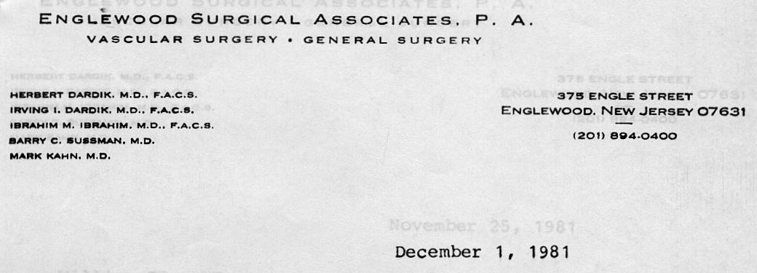
William Casey Esq.
4100 Cathedral Avenue N.W. Washington D.C. 20270
Dear Mr. Casey:
I read the article under the by-line of Jack Anderson, and was most disturbed with it's content.
When Gideon Ariel and I originally spoke to you concerning the possibility of your working with us in the development of Scientific Life Systems, the business proposal was most straightforward. You will recall that the initial intent was to establish fitness centers and market various related products, while having quality services available to diabetic children.
The center I had established involved a program for a number of medical patients, including juvenile diabetics. As a vascular surgeon, I recognized the importance of a quality nutritional and exercise program for these diabetics, employing a number of Olympic athletes to work with these children. Additionally, Dr. Ariel's computerized exercise machine and other products would be developed for marketing. The reciprocal advantages were obvious for both groups.
What I had hoped to accomplish in establishing this program was to provide employment to Olympic athletes in an area where their self-esteem could be maintained and enhanced, while providing a motivational force to diabetic children and the public. A business venture was the best way to serve these goals. Due to pressures beyond control, I was unable to follow through on the project. Both yourself and Bill Simon advised against any USOC involvement in the program. Consequently, the proposal was withdrawn. Certainly, the project never received or had any commitment from the USOC in return for any monies.
I appreciated your willingness in considering to be part of such a self sustaining entity which would have benefited athletes, diabetic children and the public as well. I regret that this article has been the source of any embarassment to you. I assure you I was never contacted by Mr. Anderson. But whomever might have been the source seems to be going all out to discredit those of us who tried to accomplishing a worthy undertaking.
Sincerely,
Irving Dardik,M.D.,F.A.C.S.
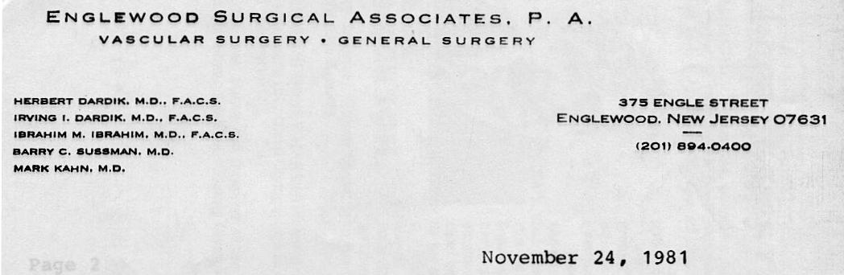
Mr. Michael Addison
Foundation Life Building 100 Twiggs Avenue
Tampa, Florida 33602
Dear Mike:
Enclosed is the article by Jack Anderson which we spoke about
on the phone today. This has certainly been a further embarassment to me.
Firstly, the United States Olympic Committee turned down my proposal that the Olympic seal be applied to a fitness center chain. I had a written proposal which I personally attached the Olympic Seal as a demonstration, but as I stated previously, this was not approved.
Additionally, when I introduced this idea to William Casey and William Simon, both felt the Olympic Seal should not be used and, in fact, the program had sufficient merit that it would not need it. Both gentlemen were very careful to point out in their discussion with me that there should be no question of a conflict of interest. Therefore, Mr. Anderson has presented a false statement in stating that:
"The company worked out an agreement with the U.S. Olympic Committee for the exclusive use of the Olympic insignia; in return, the committee would get $25 for each fitness fan who signed up at one of Scientific Life's centers."
Certainly, we never received or had any committment from the USOC for $25.00 or any monies. I thought it would be a good idea at the time to contribute money to the USOC as well. But that is all it was, a proposal.
Bill Simon and Bill Casey, tried to help me out with a program that was well intentioned and stood to provide jobs for Olympic athletes who could motivate jubenile diabetics and the public as well, while at the same time being a viable operation. So you can see, with all the adverse activity by those who sought to discredit myself and Dr. Ariel, the entire concept of Scientific Life Systems fell apart. This article seems to be just another attempt to further discredit us.
Incidentially, Mr. Anderson states that David Liskin was an Olympic bobsledder. Mr. Liskin was never an Olympic bobsledder.
Sincerely,
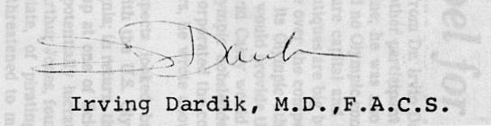

And this was the end of SLS. The two centers went on for one year, but without proper backing and attention, they lost their impetus. I had no desire to run a huge bureaucracy of training centers so I did not carry on with the idea myself. It needed businessmen to run it, not scientists.
It was a great idea, which was tarnished by the jealousy of unproductive people. And a terrible example of how the press can print stories that do not have much veracity to them. A terrible discredit to all whom were involved.
I was beginning to see there were sharks in every water and I could never get over how, once you tried to do something entrepreneurial that was well intentioned, the number of people who came out to stop you.
So it was back to our core business of analyzing athletes. At least, for now.

